Project-7:

An Auction Application:

Usecase:

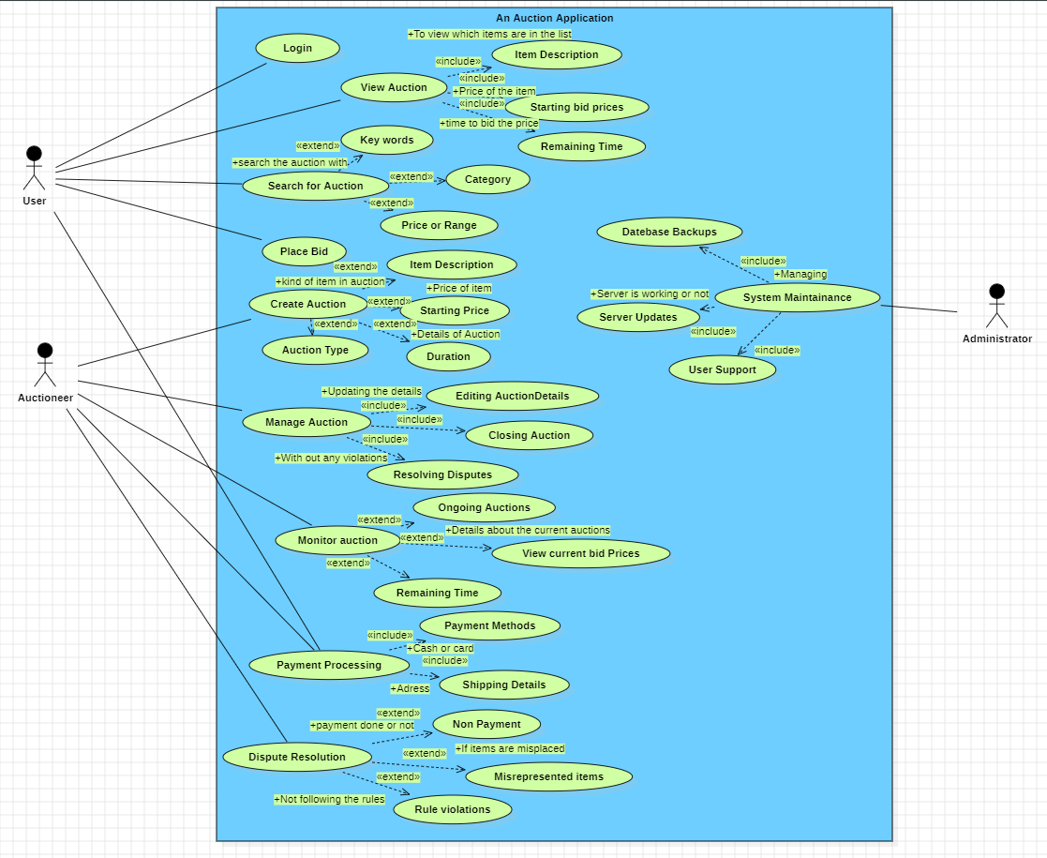

Activity diagram:

Sequence diagram

State chart:

Class diagram

